CS395

Assignment 2

Todd Carter

V01187982

**1)**

**a)**

graph a)

DFS =>

f 5,1

g 4,2

e 3,3

b 2,4 c 7,6

a 1,5 d 6,7

graph b)

Not a directed acyclic graph, so cannot be topologically sorted.

**b)**

graph a)

Source-Removal =>

f 7, 1

e 6, 2

g 5, 3

c 4, 4

b 3, 5

a 2, 6

d 1,7

graph b)

Not a directed acyclic graph, so cannot be topologically sorted.

**2)**

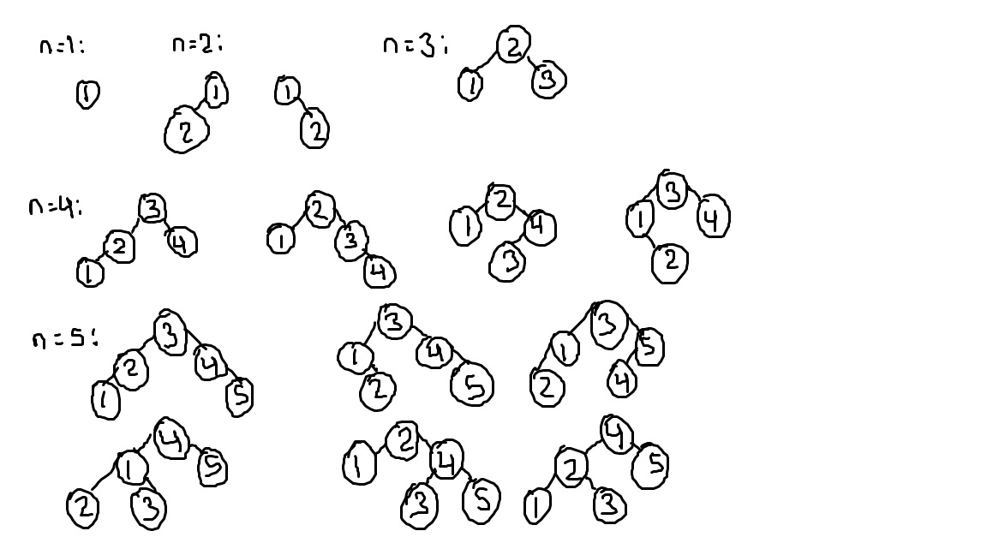

**3)**



**4)**

|  | **Unordered array** | | **Ordered array** | | **Binary search tree** | | **Balanced search tree** | | **hashing** | |
| --- | --- | --- | --- | --- | --- | --- | --- | --- | --- | --- |
|  | Average case | Worst case | Average case | Worst case | Average case | Worst case | Average case | Worst case | Average case | Worst case |
| **search** | O(n) | O(n) | O(log n) | O(log n) | O(log n) | O(n) | O(log n) | O(log n) | O(1) | O(n) |
| **insert** | O(1) | O(1) | O(n) | O(n) | O(log n) | O(n) | O(log n) | O(log n) | O(1) | O(1) |
| **delete** | O(n) | O(n) | O(n) | O(n) | O(log n) | O(n) | O(log n) | O(log n) | O(1) | O(n) |

**5)**

**a)**

**Selection Sort:**

n-1 n-1 n-1

$Σ$ $Σ$ (1) => $Σ$ (n-i-1+1)

i=0 j=i+1 i=0

n-1 n-1

= n $Σ$ (1) - $Σ$ (i)

i=0 i=0

= n(n-1+1) - ((n-1)(n-1+1))/2

= (2n2/2) - ((n2 - n)/2)

= n(n-1)/2

=> 2)

**Insertion Sort:**

n-1 i-1 n-1

$Σ$ $Σ$ 1 => $Σ$ (i-1-0) + 1

i=0 i=0 i=0

n-1

= $Σ$ (i)

i=0

=((n-1)(n-1+1))/2

= n(n-1)/2

=> 2)

**Quick Sort:**

q(n) = 2q(n/2) + n

Using the Master Theorem,

a = 2, b = 2, d = 1

a = bd

2 = 21

So, complexity is:

$θ(n$ log n)

**5)**

**b)**

In selection sort and insertion sort, we can see how the time duration increases by 100, or 102, each increase in complexity.

In quick sort, we can see the time goes up by a factor of 2 log10(2), which is slightly more than 10, but much less than the duration increase from insertion or selection sorts.

Results from assignment:

+------------------------------------------------+

| Number of elements: 1000

| Selection sort time: 1487.0 sec

| Insertion sort time: 782.0 sec

| Quick sort time: 67.0 sec

+------------------------------------------------+

| Number of elements: 10000

| Selection sort time: 145872.0 sec

| Insertion sort time: 78504.0 sec

| Quick sort time: 696.0 sec

+------------------------------------------------+

| Number of elements: 100000

| Selection sort time: 14531123.0 sec

| Insertion sort time: 7770646.0 sec

| Quick sort time: 7672.0 sec

+------------------------------------------------+

**6)**

**a)**

Text: CCCCCCCCABC

Pattern: ABC

**b)**

Text: ABABABABC

Pattern: ABC

Horspool:

ABABABABC

ABC

ABC

ABC

ABC

Boyer-Moore:

ABABABABC

ABC

ABC

ABC

They are different since Boyer-Moore checks from both sides of the text, rather than Horspool which checks from the left. Horspool will take longer as it will have more false positives while checking.